Hemp Canker Life Cycle (Sclerotinia sclerotiorum) diagram:

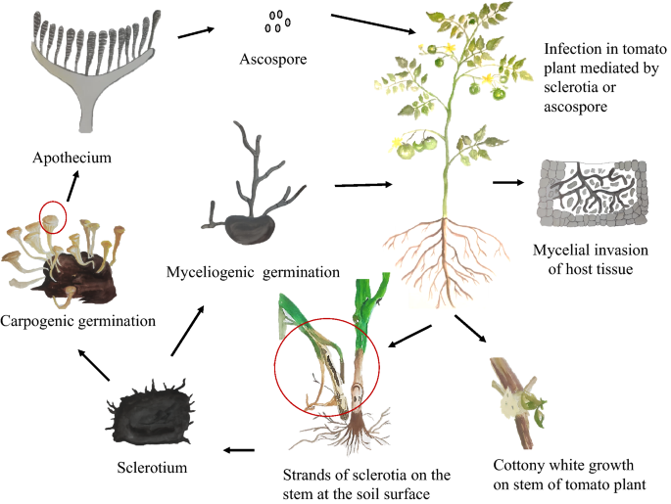
Mazumdar, P. Sclerotinia stem rot in tomato: a review on biology, pathogenicity, disease management and future research priorities. J Plant Dis Prot 128, 1403–1431 (2021). https://doi.org/10.1007/s41348-021-00509-z

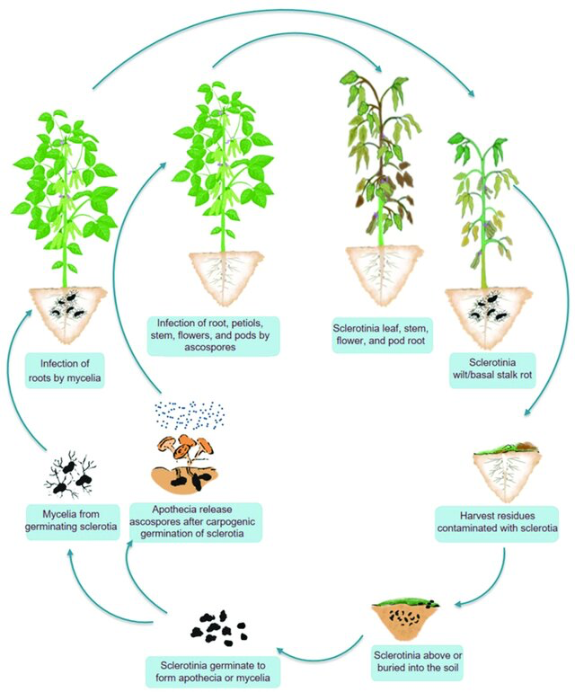
Hossain, M.M.; Sultana, F.;
Li, W.; Tran, L.-S.P.; Mostofa, M.G.
Sclerotinia sclerotiorum
(Lib.) de Bary:
Insights into the Pathogenomic
Features of a Global Pathogen.

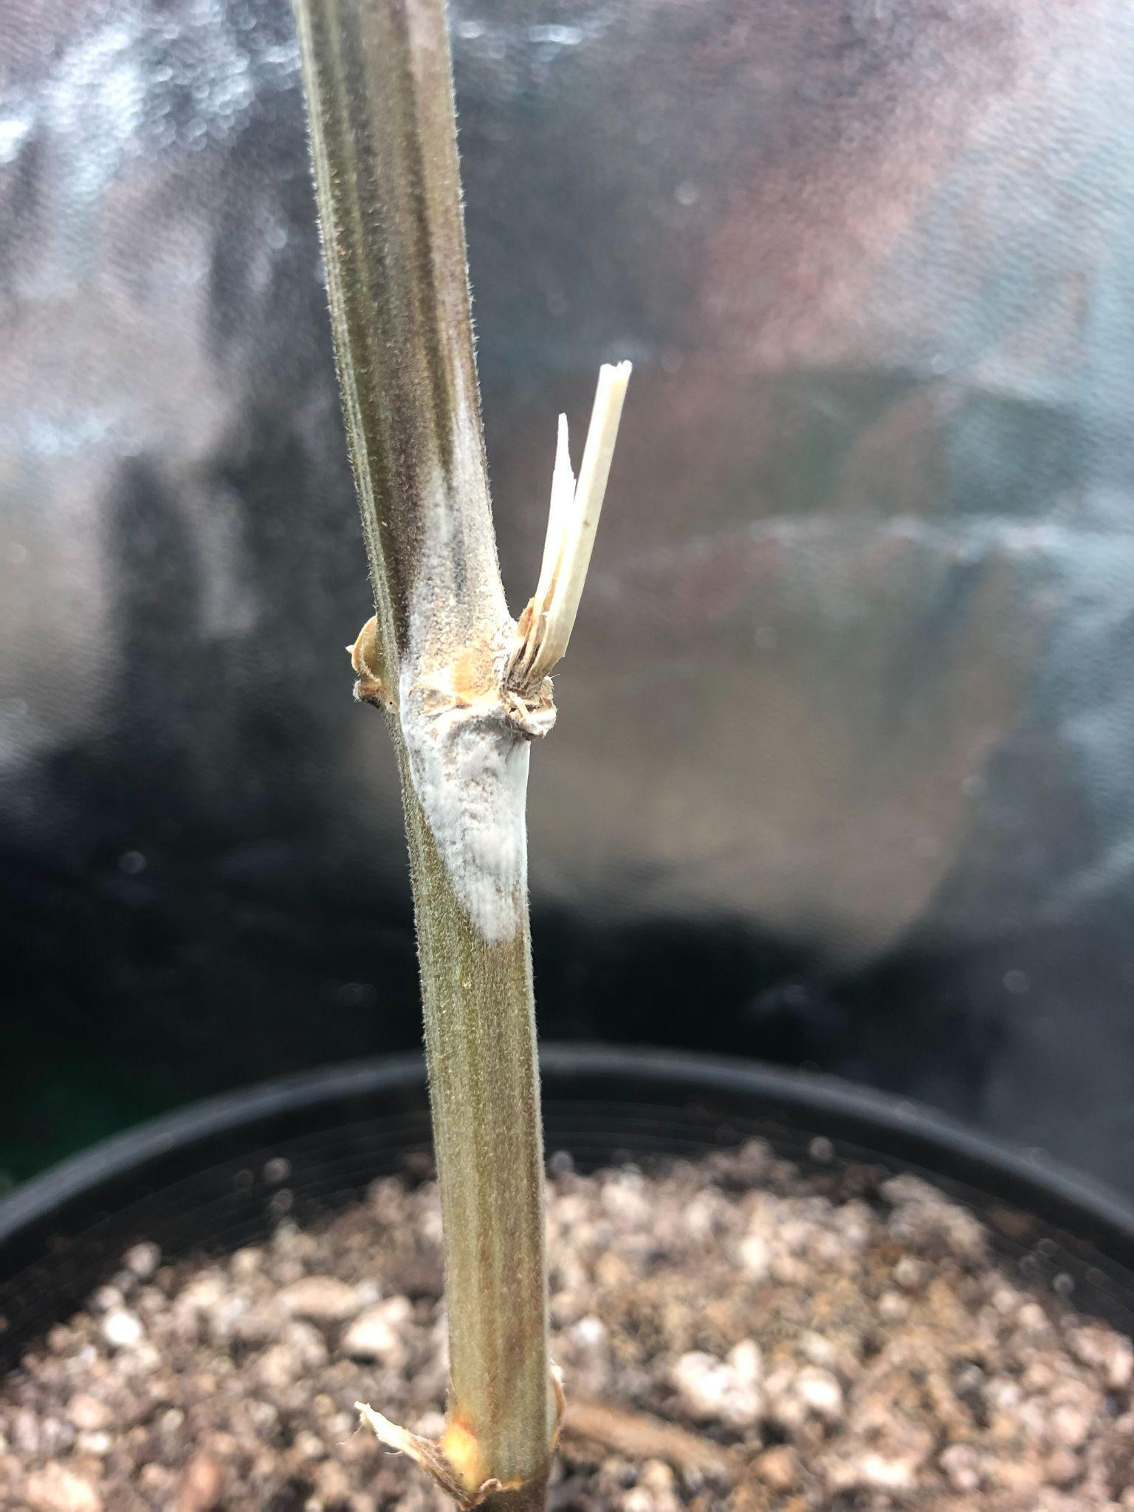

The life cycle of Sclerotinia sclerotiorum is monocyclic, meaning it doesn't produce secondary inoculums. The life cycle of this fungus can be summarized as follows:
- Sclerotium production: In late summer or early fall, the fungus produces sclerotia, which are hard, black resting bodies that can survive in soil for years. Sclerotia can form on or inside the tissues of a host plant.
- Sclerotium germination: When conditions are right, sclerotia can germinate to produce hyphae or apothecia:
  - Hyphae: Hyphae infect the lower parts of plants, like leaves and stems.
  - Apothecia: Apothecia are small stalks with a cup-like structure that contains asci, which contain ascospores.
  - Ascospore release: Ascospores are released from the asci and carried by the wind to infect other parts of the plant.
- Infection: Ascospores infect the plant's tissue, and the fungus invades the plant with mycelium.
- Mycelium growth: White, fluffy mycelium grows on the infected plant tissue.
- Sclerotium production again: At the end of the growing season, the fungus produces more sclerotia.
Structures:

- Mycelium infecting roots of plant host
- Sclerotia
- Apothecium
- Ascospores
- Cottony mycelium infecting plant stem near soil

